Coffee & Bean

Continuous Assessment 2 (CA-2)

Danielle Caroline da S. Medeiros - 23385731

Deysemare Menezes Santos - 23157607

Vinícius Araújo dos Santos - 23409622

HDCSDEV_INT - Web Design and Client-Side Scripting

Higher Diploma in Science in Computing

**29 November 2024**

Eugene McLaughlin

**Index**

1. Project Summary 1

2. Collaborative effort 2

3. Design Process 3

4.1. Presenting of data 3

4.2. Specifications and Technical Strategy 4

5. Layout e Wireframe 4

5.1. Layout 4

5.2. Wireframe 5

6. Collaborative effort 9

6.1. Task Dissection 9

7. Development 10

7.1. Bootstrap 10

7.2. jQuery 11

7.3. Validation 12

7.4. CSS Validation 17

7.5. Responsive Validation Mobile 19

8. Conclusion 31

9. Reviews 31

10. References 32

# Project Summary

We chose the Coffee Shop theme because of our passion for coffee and its cultural significance, as well as its universal appeal. Coffee is more than a drink… It represents energy, comfort, and community, making it an ideal focus for our project.

The problem we aim to solve is the lack of a centralized, user-friendly platform where customers can know about the coffee making process, find detailed information about coffee services, and connect with the rich history of coffee. By offering a seamless online experience, we bridge the gap between curiosity and accessibility, enhancing the overall journey for coffee lovers.

The market for coffee is vast and ever-growing. According to *BrewSmartly*, Dublin is the second most coffee-obsessed capital in Europe, with 181 coffee shops per 100,000 people and an estimated 2 billion cups consumed daily. This demonstrates not only the love for coffee but also the immense potential for innovation in this space.

# Collaborative effort

Our team collaboratively decided to base our project on the theme of coffee. To ensure an equitable workload, we divided the six pages of the project into two types for each team member: one simpler, informational page, and one more complex page requiring user interaction or the creation of advanced elements.

After defining the responsibilities for each page, we distributed additional tasks—such as reviewing and maintaining the general CSS, debugging JavaScript, and assembling the final report to ensure that everyone contributed to all aspects of the project. This balanced approach prevented an unequal division of effort while fostering teamwork.

**Page Assignments and Deliverables:**

* Daniele: Responsible for the About Us and Coffee Stores pages.
* Deysemare: Responsible for the Home Page (index.html) and Contact Us pages.
* Vinícius: Responsible for the Our Grains and Bean Boutique pages.

Each page must adhere to the established layout and style guidelines, which include using general and individual-specific CSS files. Deliverables for each page also incorporate requirements like the use of Bootstrap, JQuery, and JavaScript.

**Tools and Workflow:**

To manage the project efficiently, we utilized:

* **Trello** for activity mapping, task distribution, and progress tracking.
* **GitHub** for deployment and synchronization of individual contributions.
* **Visual Studio Code** for coding, leveraging its integration with GitHub to streamline collaboration

**Milestones:**

1. Page Design Completion: Layouts and wireframes finalized.
2. Coding Phase: HTML, CSS, and JavaScript implementation for each page.
3. Testing and Review: Collaborative testing of functionality and design consistency.
4. Final Submission: Assembling the report and deploying the final version.

This approach ensured a structured workflow with clear deliverables and milestones, while fostering collaboration across all project stages.

# Design Process

To design our site, we started by researching Irish coffee shop websites to understand the prevailing styles and identify elements that resonated with our project’s theme. Additionally, we explored other websites with visually appealing designs to gather broader inspiration. Based on our findings, we created several drafts, refining them collaboratively until we reached a design that satisfied everyone in the group. After finalizing the concept, we developed detailed wireframes for each page. These wireframes served as a blueprint, ensuring consistency across the layout and streamlining the design process for all group members.

## Wireframe

### Index

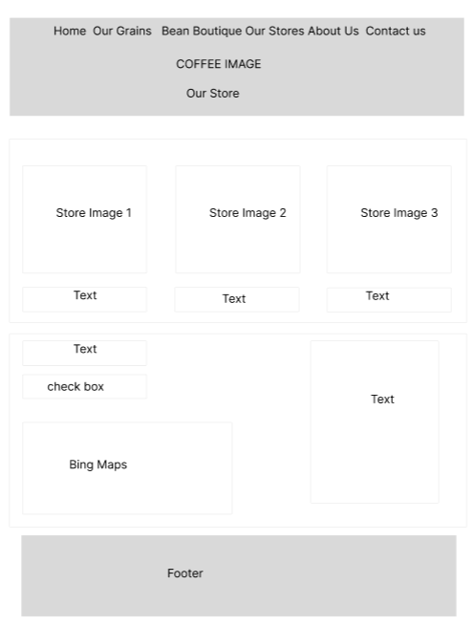

### Our Grains

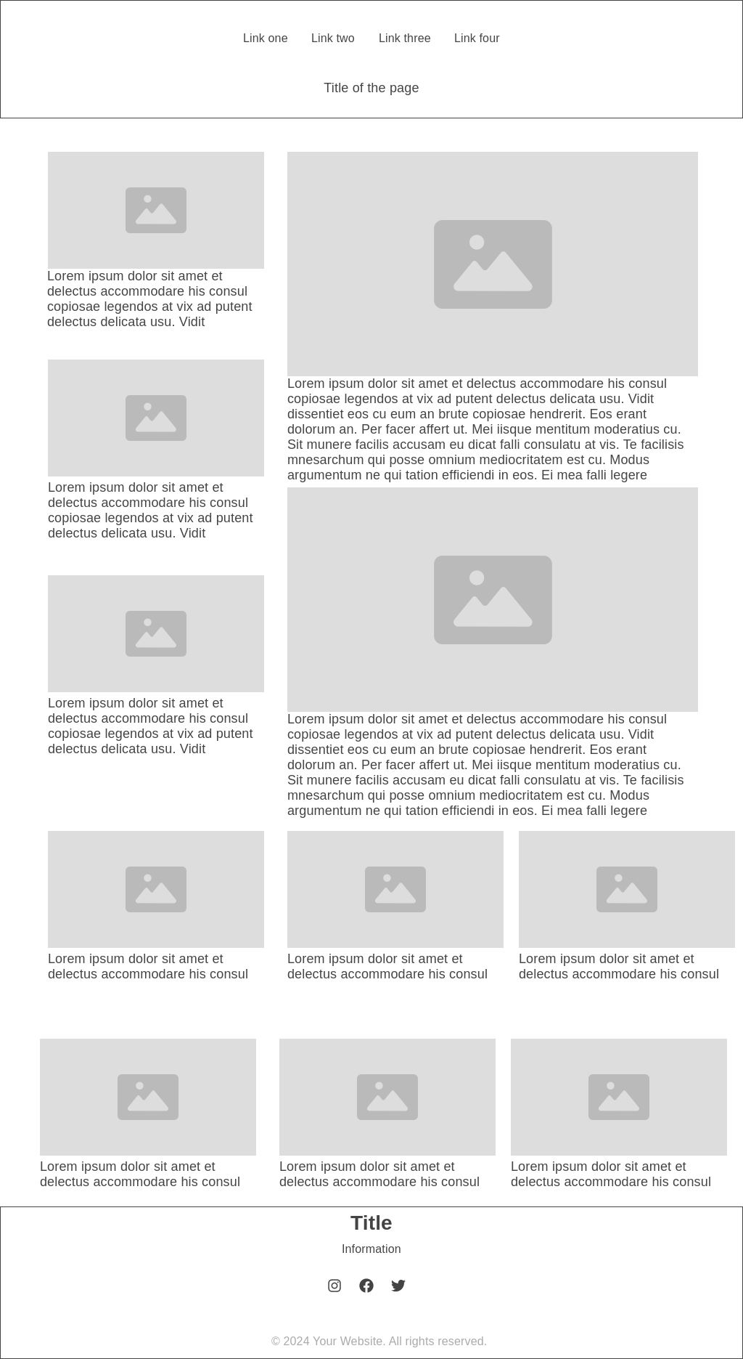

### Beans Boutique

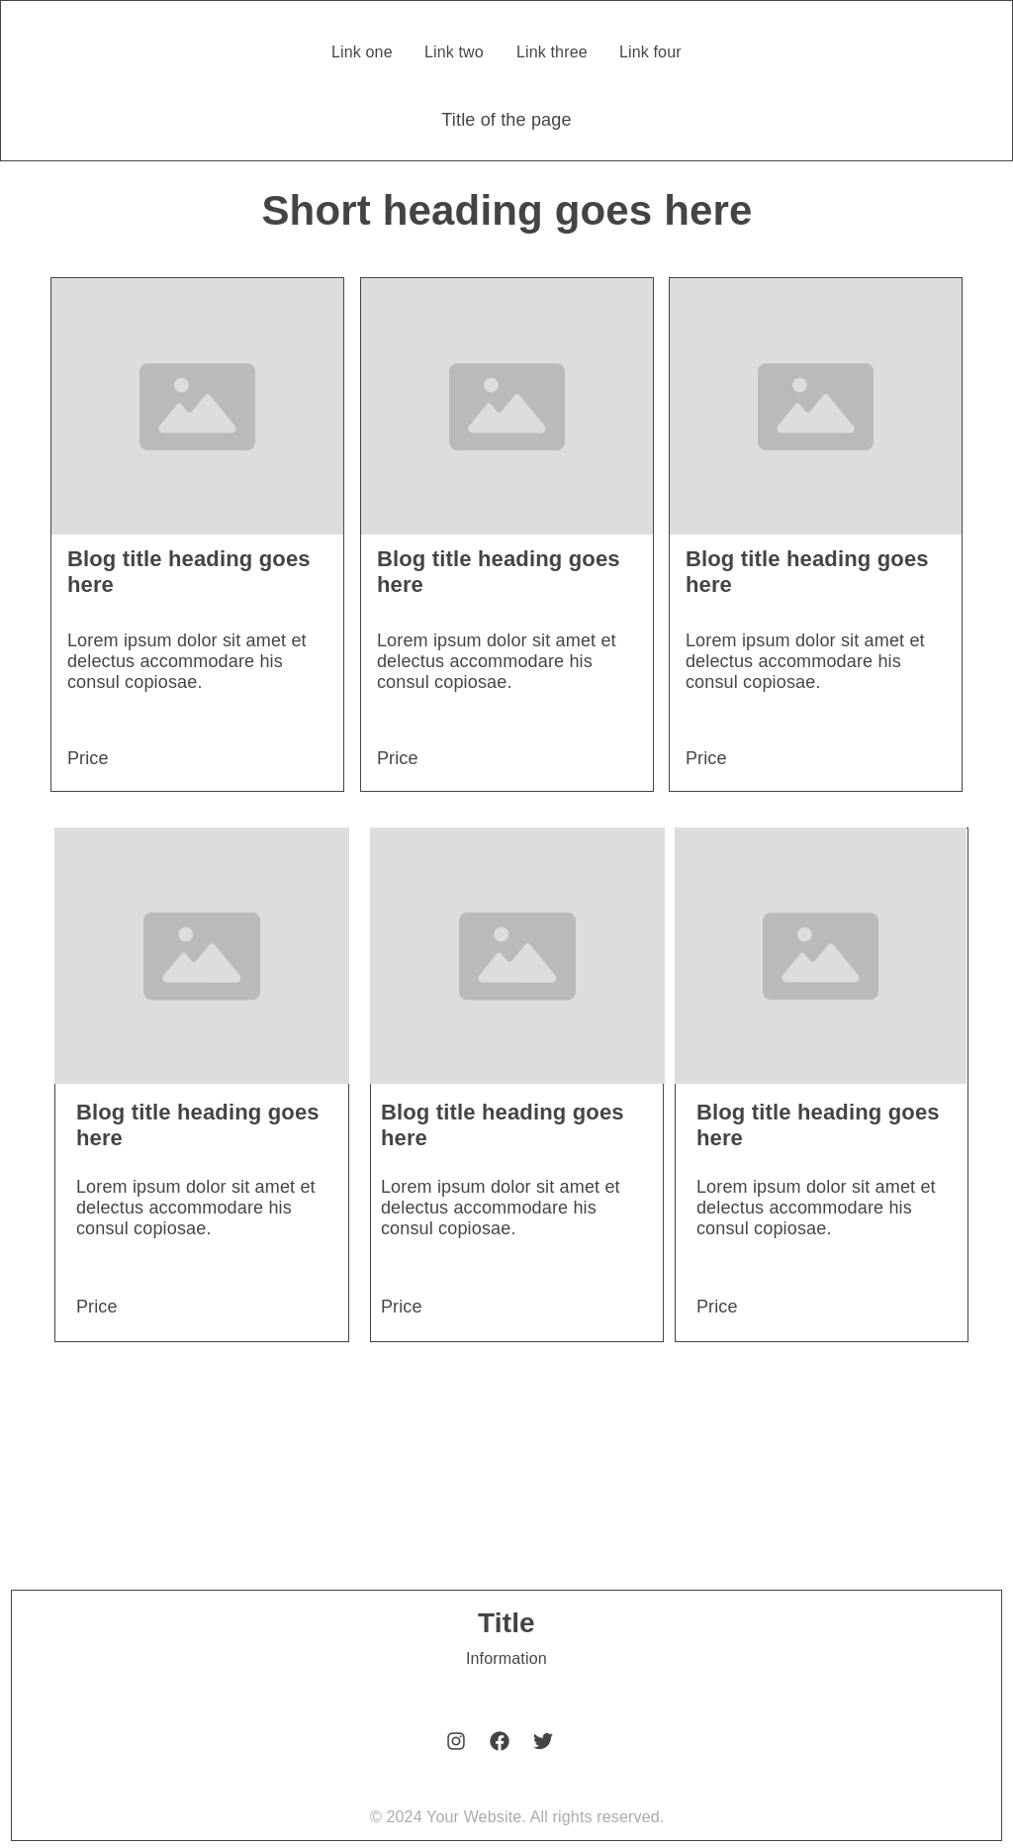

### Our Stores



### About Us

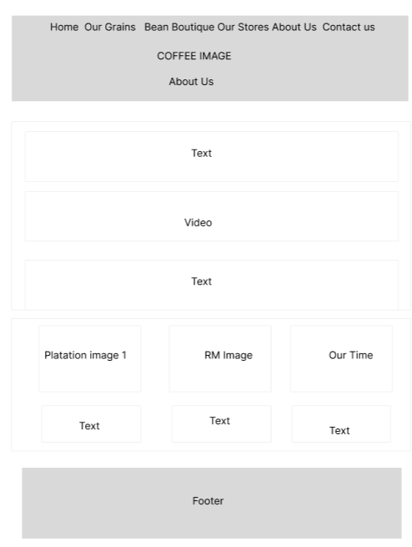

### Contact Us

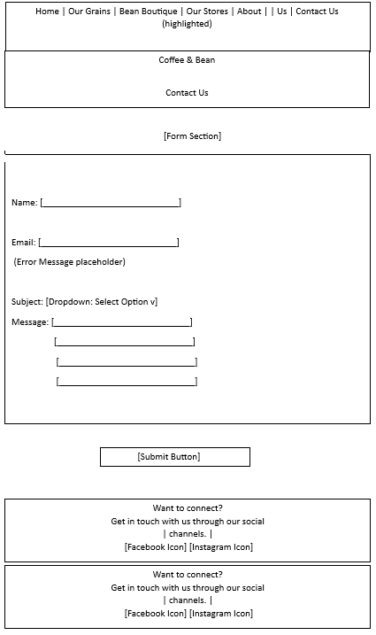

# Development

## Bootstrap

Bootstrap provides a robust, responsive framework that accelerates the development process while ensuring a cohesive and consistent design across the website. By leveraging Bootstrap, the project benefits in several key ways:

* Increased productivity: Ready-made components reduce the need for custom coding.
* Guaranteed responsiveness: Ensures the website is mobile-friendly and adapts seamlessly to various screen sizes.
* Cross-browser compatibility: Addresses inconsistencies across different web browsers.

In this project, Bootstrap has been implemented to deliver responsive layouts and stylized components efficiently, enabling faster development and a polished, user-friendly design.

Example of code where we applied bootstrap:

<div class="col">

<div class="card h-100">

<img src="images/colombian-coffee-beans-guide.jpg" class="card-img-top"

alt="Colombian Coffee">

<div class="card-body">

<h5 class="card-title">Colombian Coffee</h5>

<p class="card-text">

Colombia ranks among the top coffee producers worldwide, with beans known for their balanced flavors, medium body, and bright acidity. Colombian coffee offers diverse taste profiles, often featuring smooth notes of caramel, citrus, and chocolate.

</p>

</div>

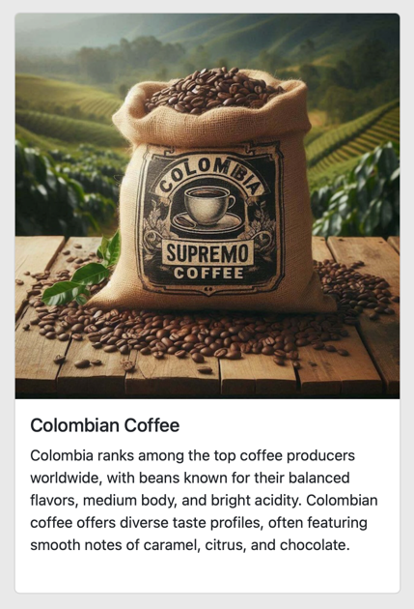 </div>

</div>

## jQuery

jQuery is a lightweight JavaScript library that simplifies HTML DOM manipulation, event handling, and animations, enhancing interactivity and user experience on a website. Its simplicity and cross-browser compatibility make it an excellent choice for web development, especially when implementing interactive features efficiently.

In our project, jQuery was utilized to enhance the responsiveness and usability of the website’s navigation menu, particularly for mobile devices. To achieve this, we implemented the *jquery.scrollex* plugin, which provides a powerful way to trigger animations and actions based on scrolling behaviour.

The use of *jquery.scrollex* allowed us to create a dynamic menu that adapts seamlessly to the user’s scrolling actions, ensuring the menu:

* Remains accessible: Improves navigation in the mobile view by dynamically showing or hiding menu elements as needed.
* Improves performance: Optimizes mobile interactivity by focusing only on active sections of the page.

This implementation ensures that the navigation menu delivers a clean and user-friendly experience, aligning with modern design standards and the responsive nature of the website.

As you already know, jQuery is used to link elements in HTML and is one of the most popular libraries used. we apply responsiveness to the pages, meaning that if accessed from another platform, the quality of the visualisation is not lost, especially in the menu, which needs to be visible if the website is accessed via mobile phone.

Fig 14. Our Stores As the page is reduced in size, the quality of the menu and the visualisation of the content is not lost.  
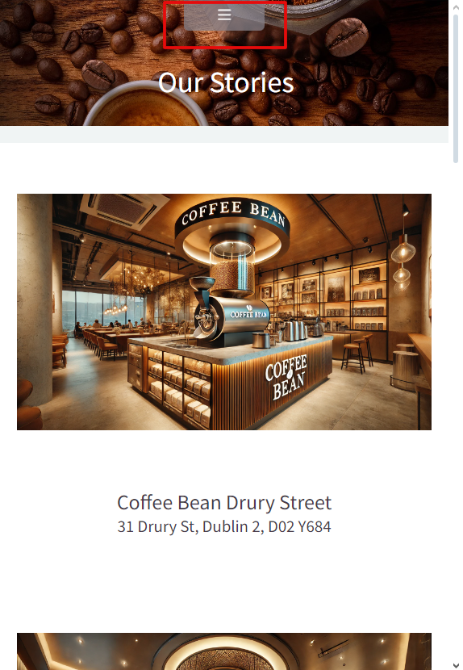

## Validation

The website was validated before it was uploaded.

Fig 15. About Us Html Validation

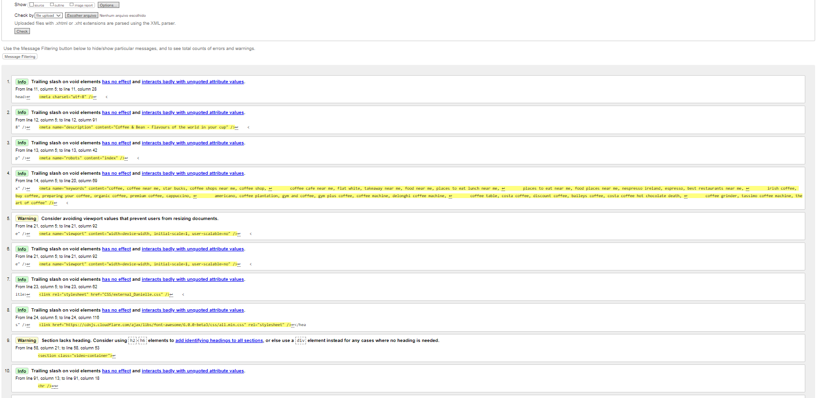

Fig 15.1.About US Html Validation an error found in the footer section.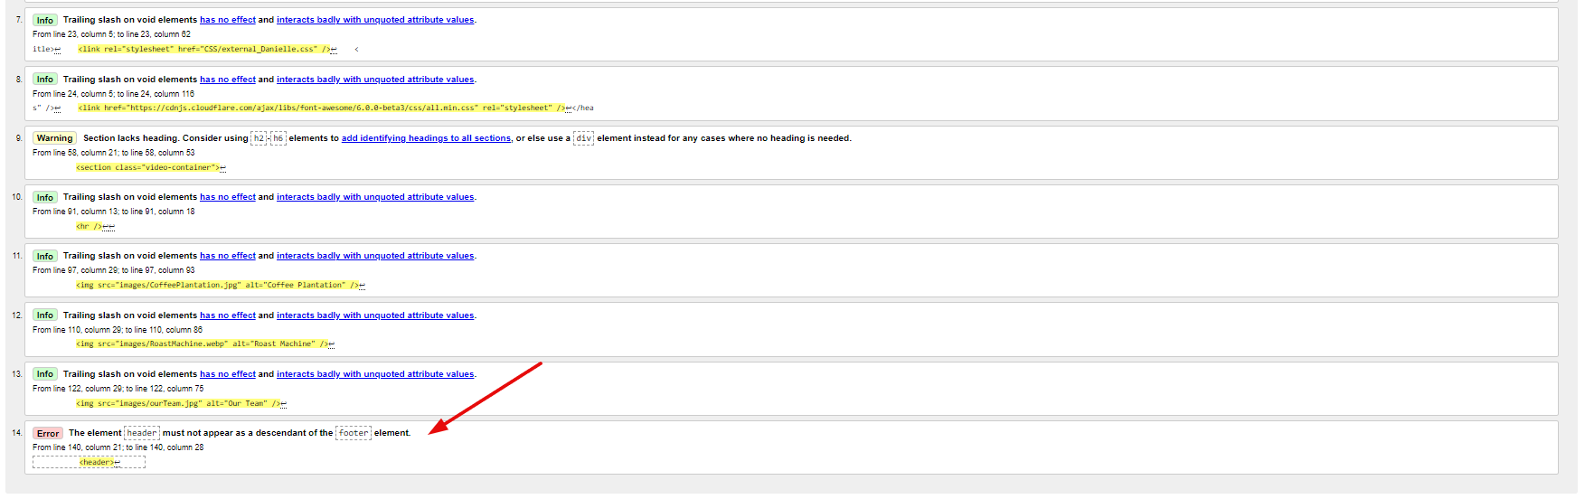

Fig 16. Our Store Html page.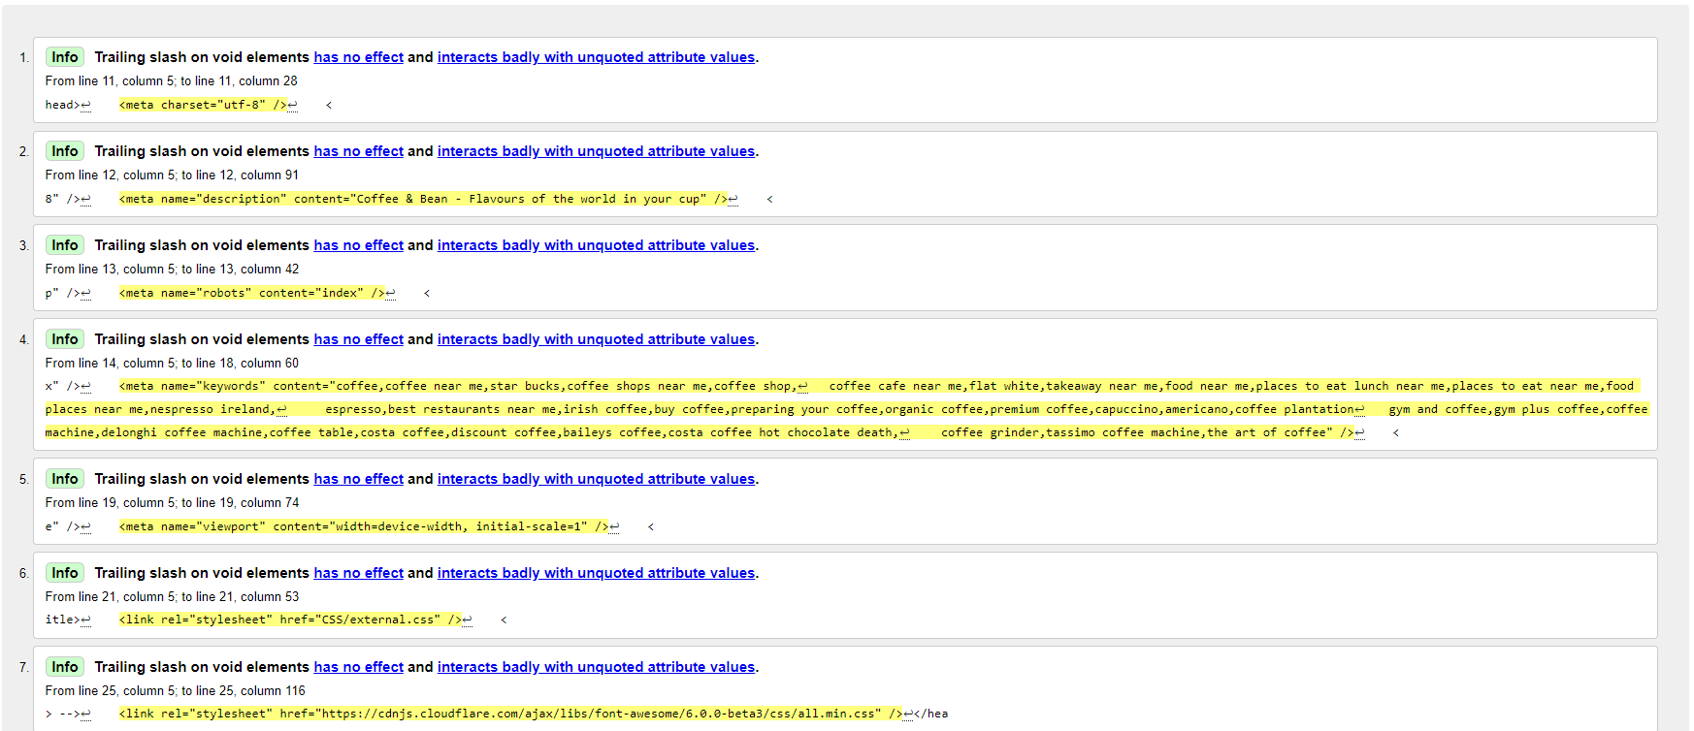

Fig 16.1. Our Store Html an error found in the footer section.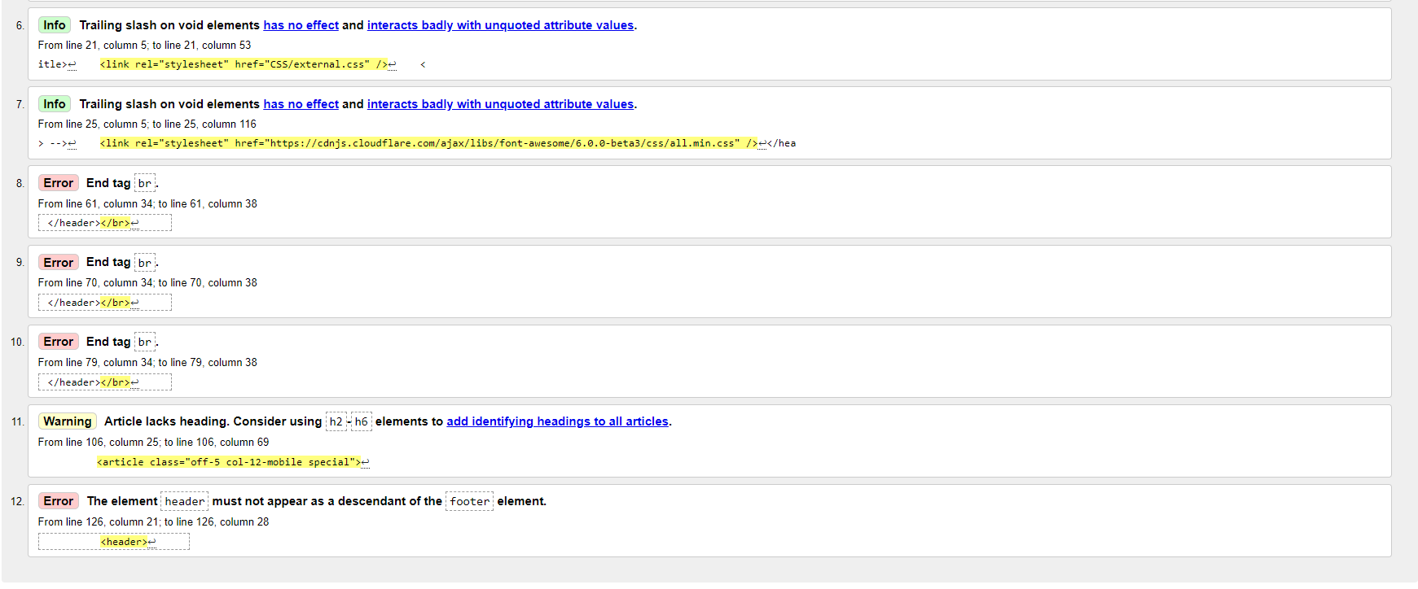

Fig 17. Bean Boutique.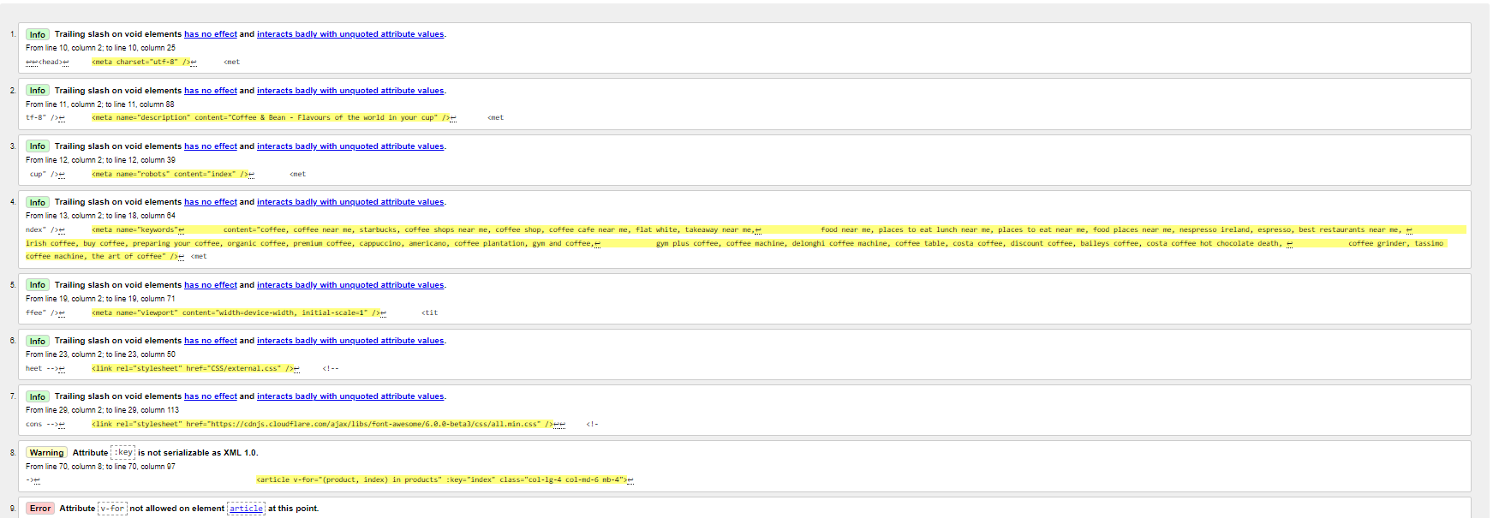

Fig 17.1 Bean Boutique.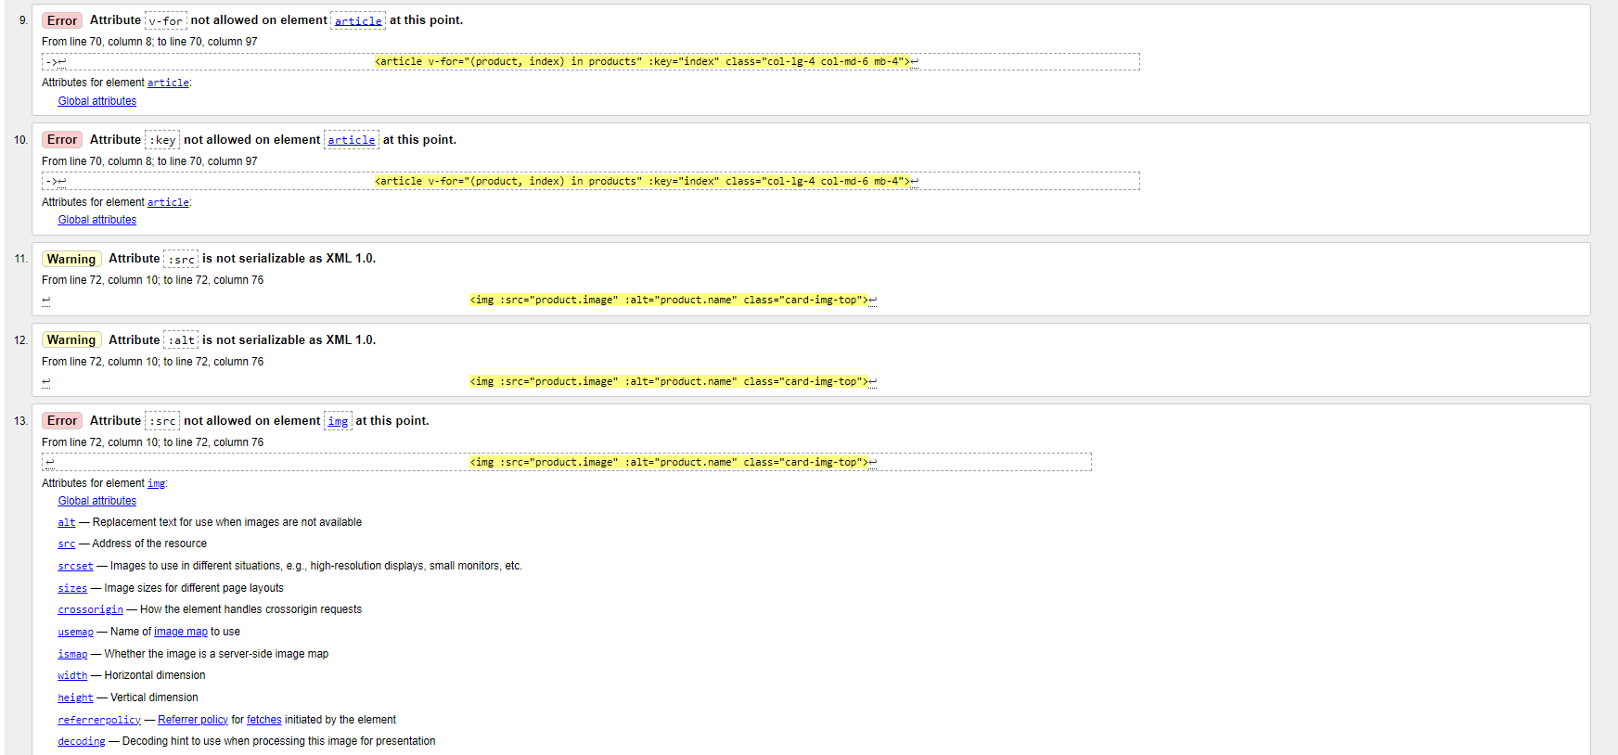

Fig 17.2 Bean Boutique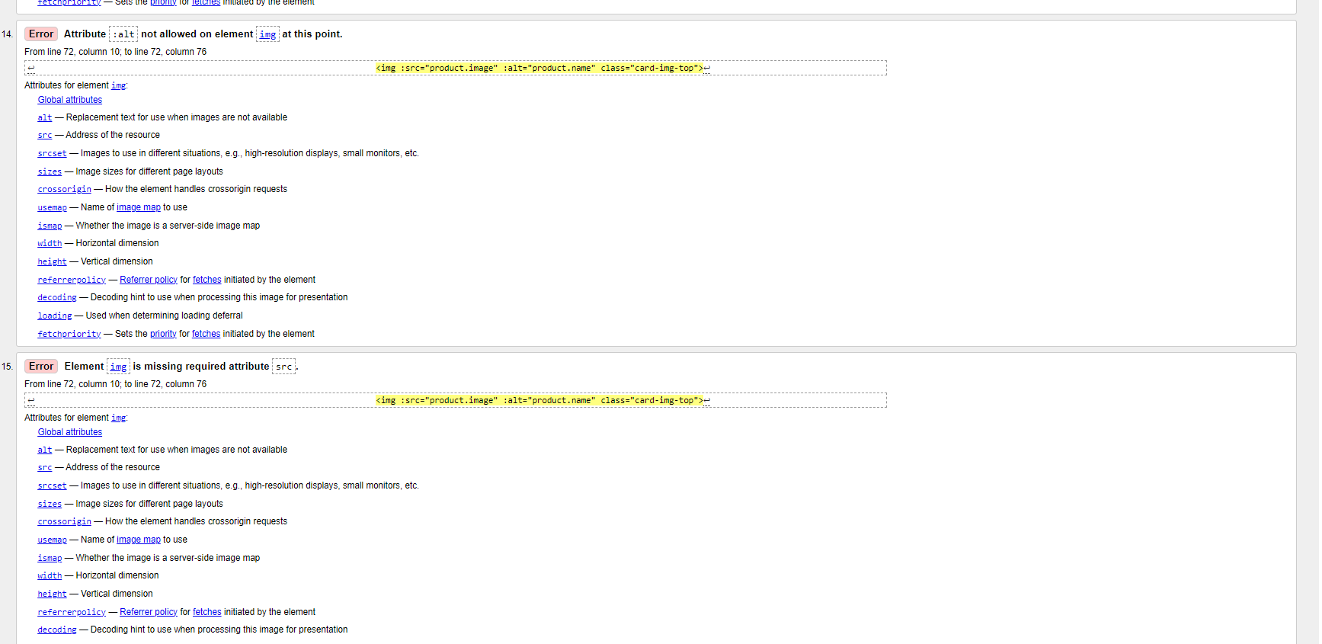

Fig 17.3 Bean Boutique.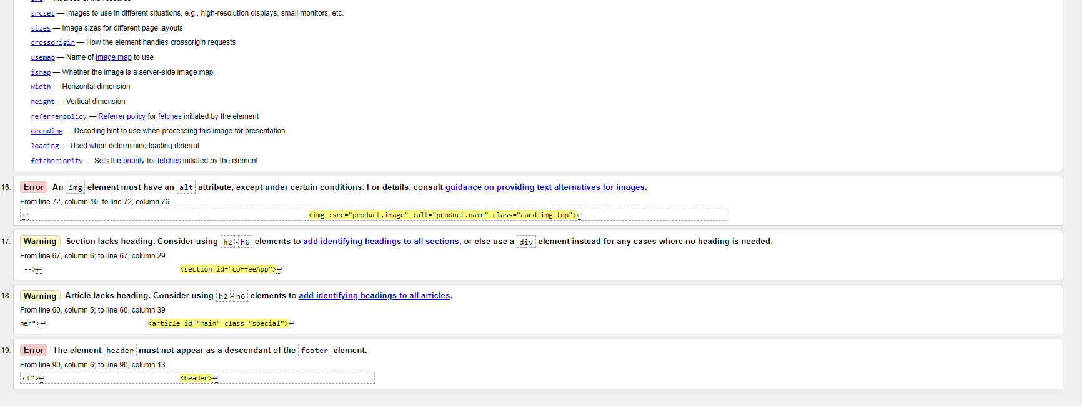

Fig 18. Our Grains.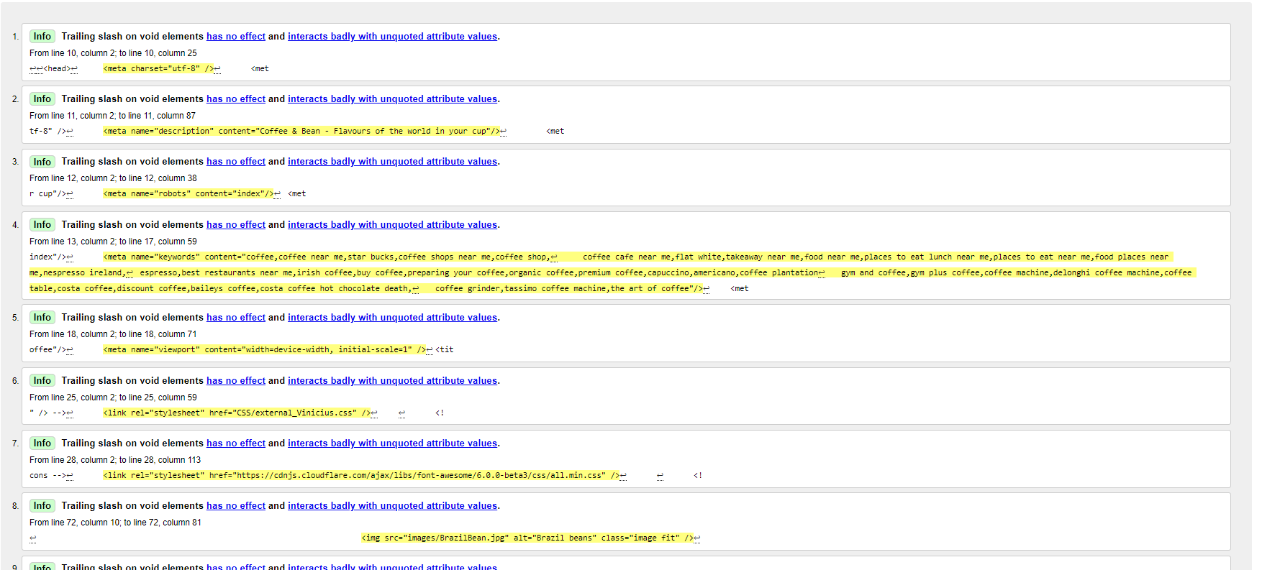

Fig 18.1 Our Grains.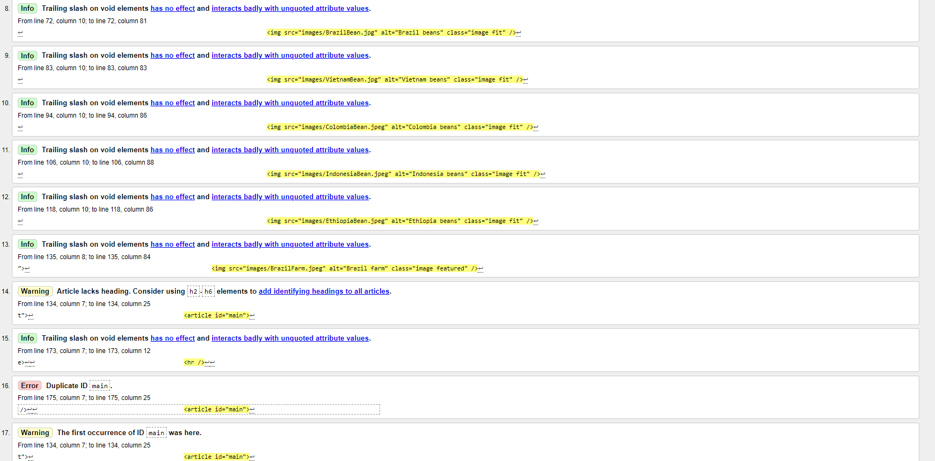

Fig 18.2 Our Grains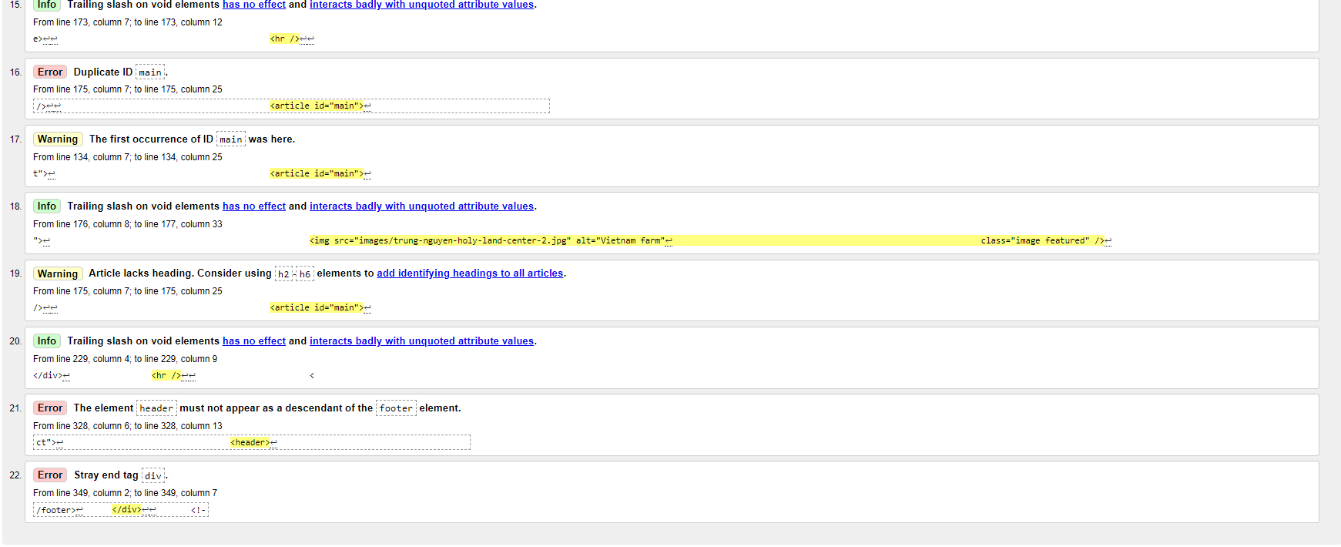

Fig 19. Contact Us Html Page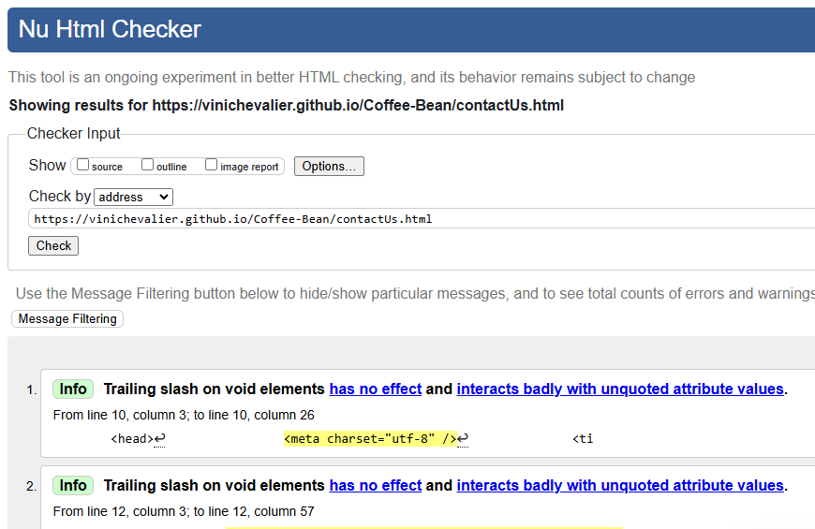

Fig 20. Home(index) Page Html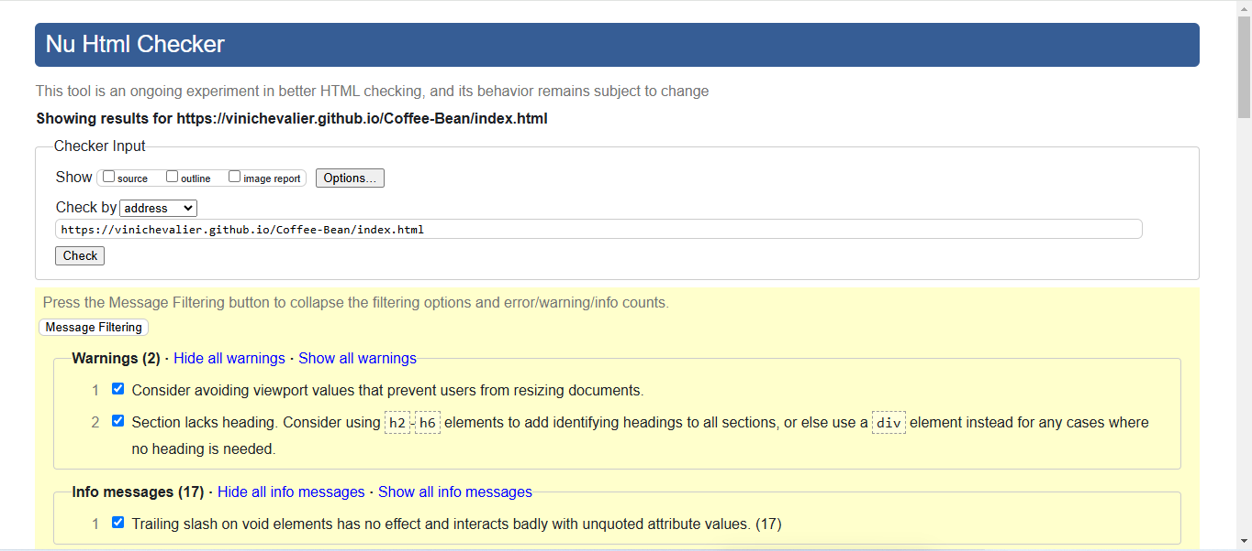

## CSS Validation

Fig 21. Deyse_css 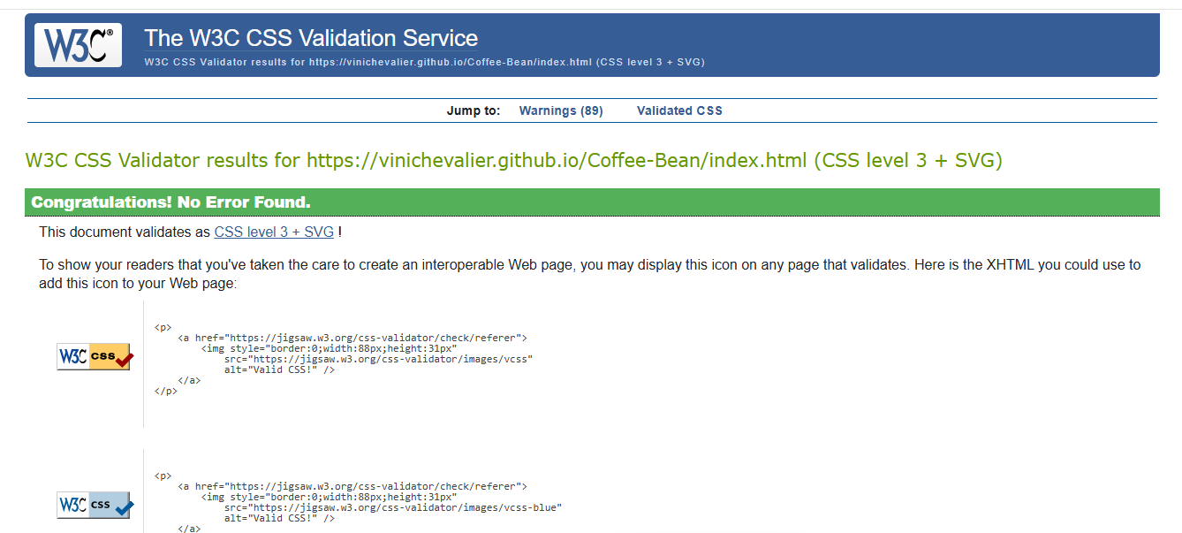

Fig 22. Danielle_css.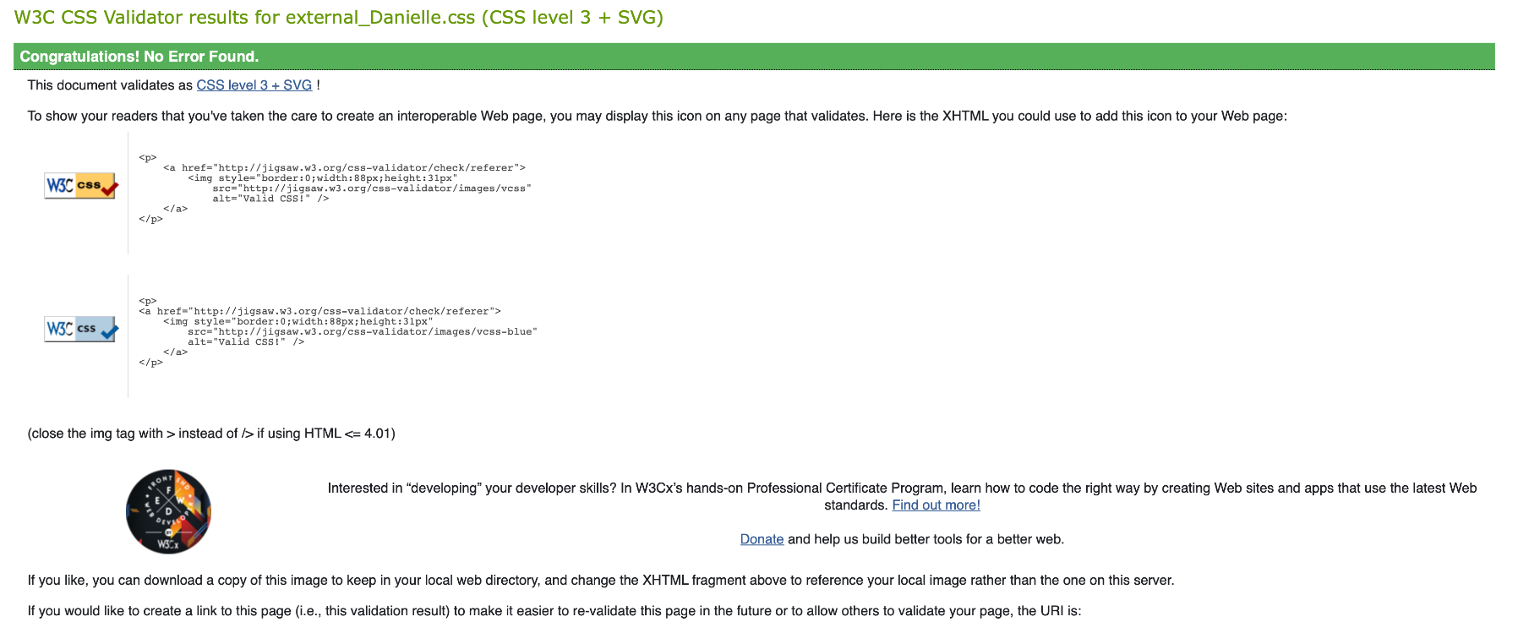

Fig 23. Vinicius_css.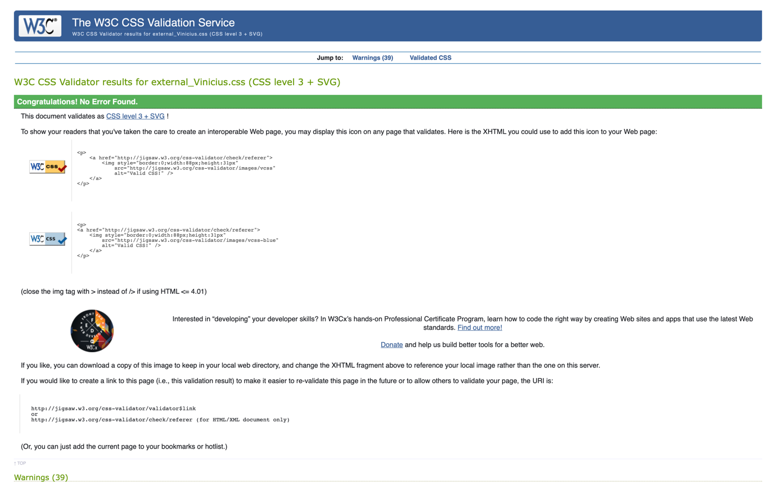

Fig 24. External_css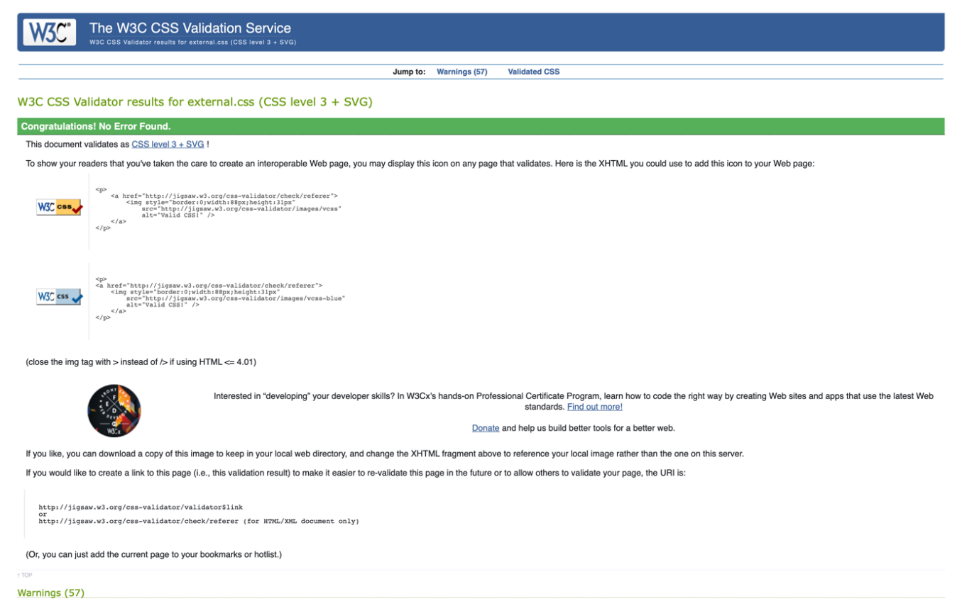

## Responsive Validation Mobile

Offering more quality to the website, responsiveness can be visualised in the texts and images inside the tags.

Fig 25. About Us page. 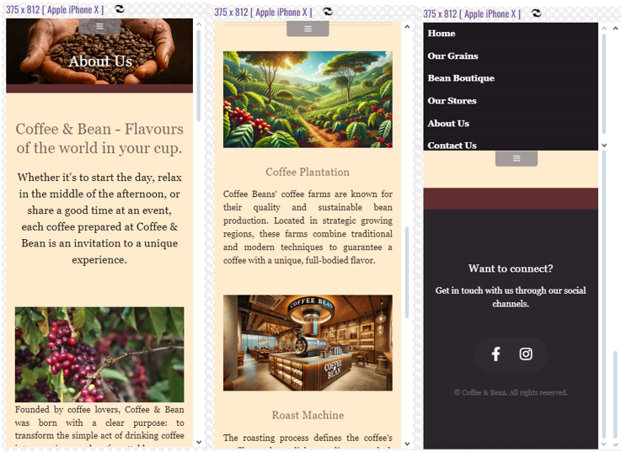

Fig 26. Our Store.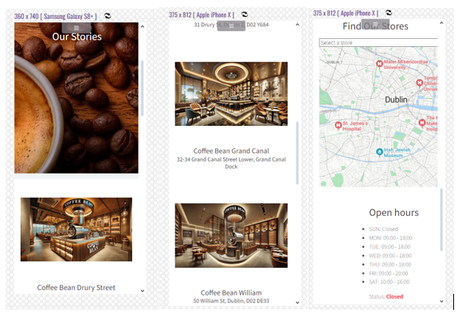

Fig 27. Home Page.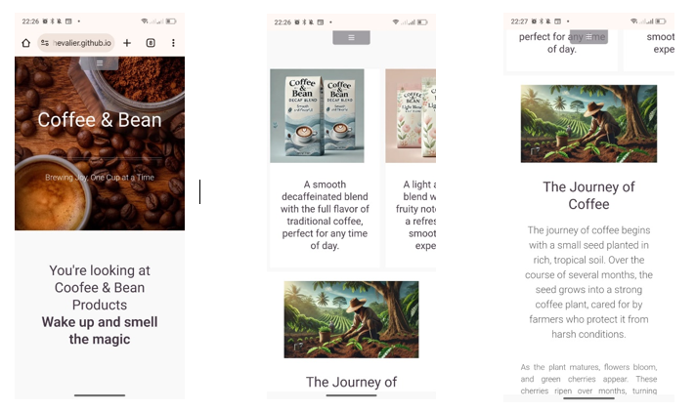

Fig 28. Contact Us.

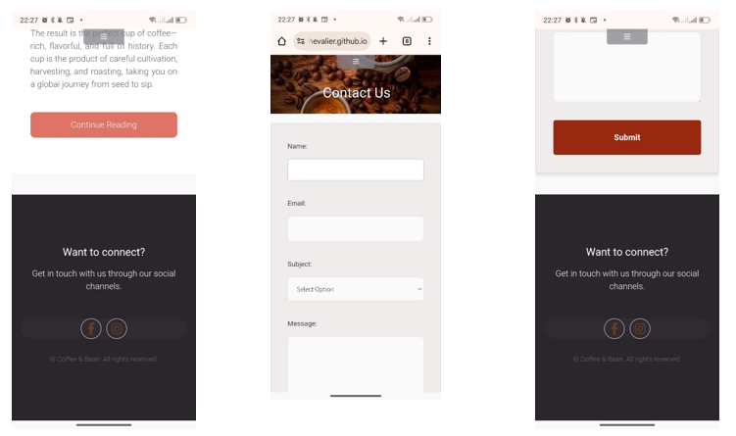

Fig 29. Our Grains.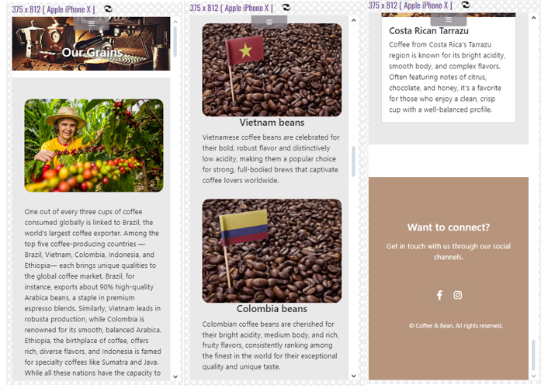

Fig 30. Bean Boutique.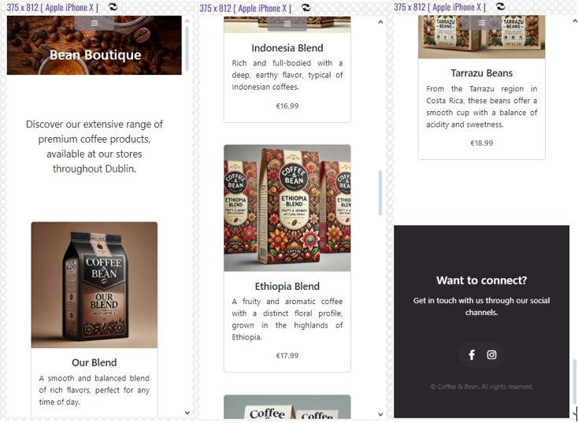

4.5 Responsive validation Desktop.

Fig 31. validation performed Our Stories on Desktop 1024x768.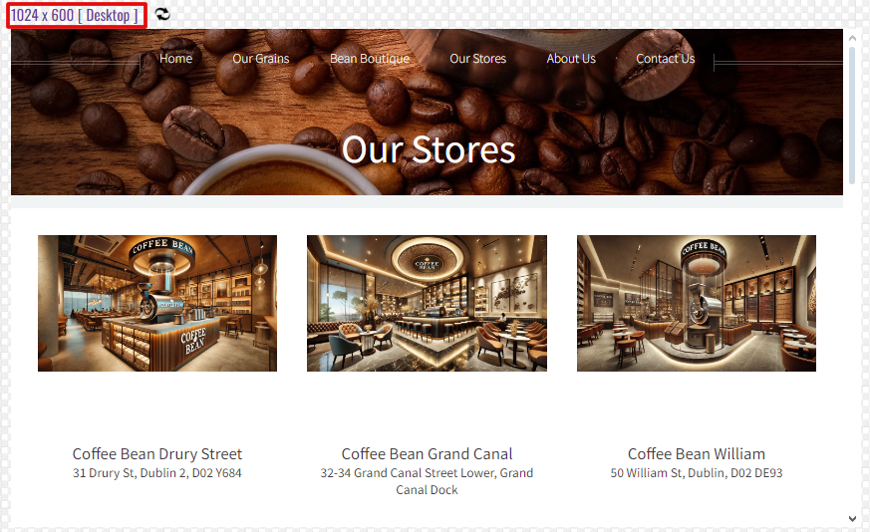

Fig 32. validation performed About Us on Destktop 1024x768. 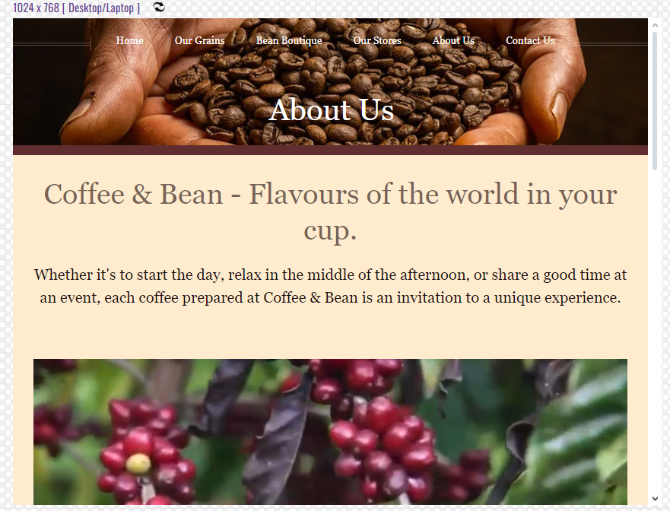

Fig 33. Microsoft Edge(browser) Contact US on Destktop .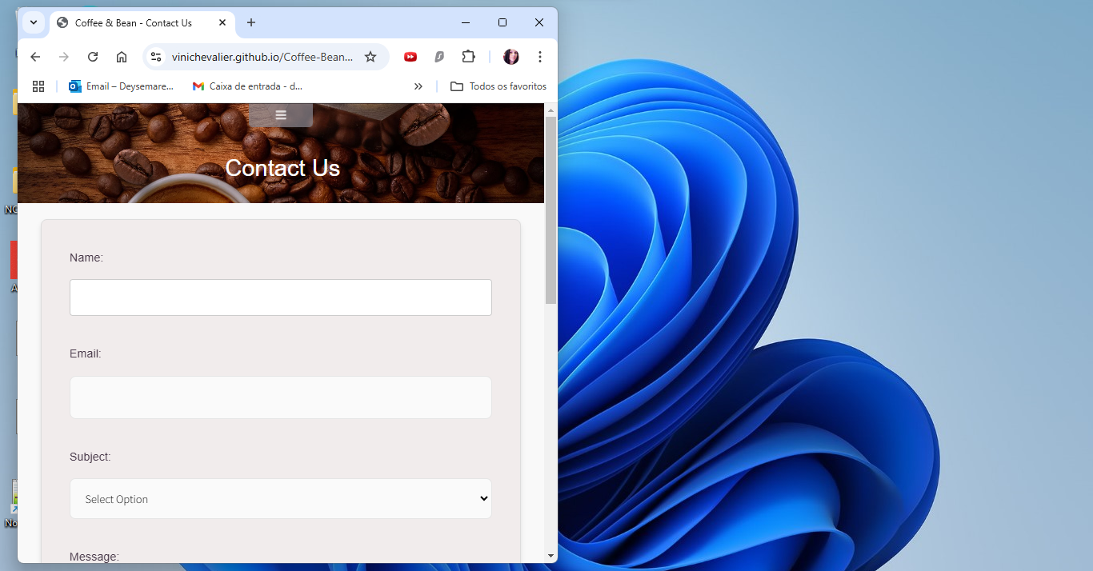

Fig 34. Microsoft Edge(browser) Home Page on Destktop 1024x768.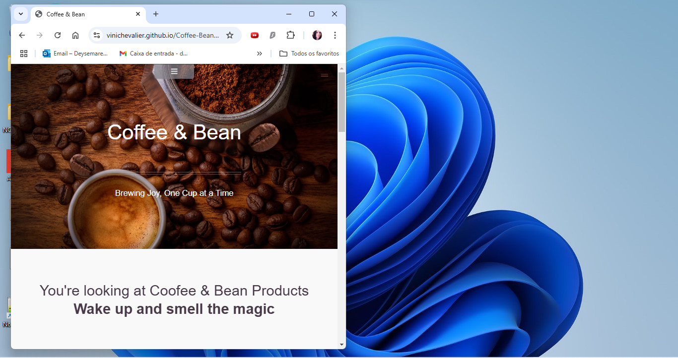

Fig 38. Google Chrome carousel Home page validation.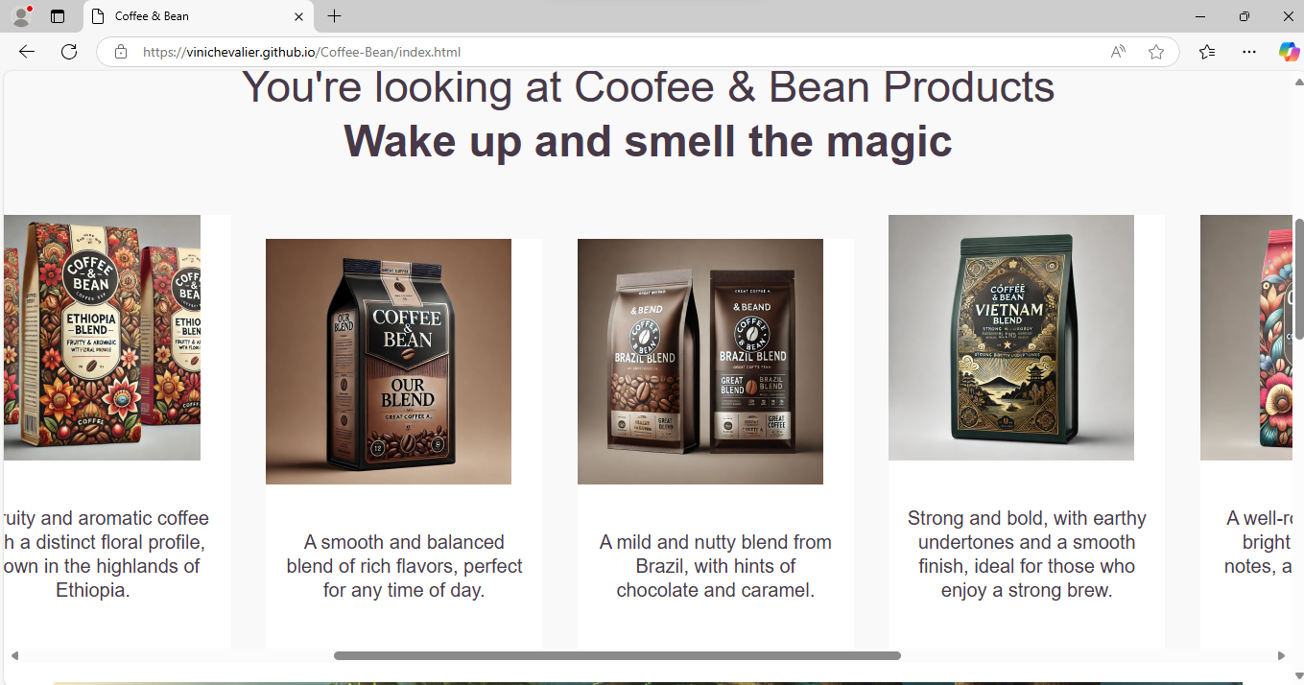

Fig 36. Google Chrome carousel validation.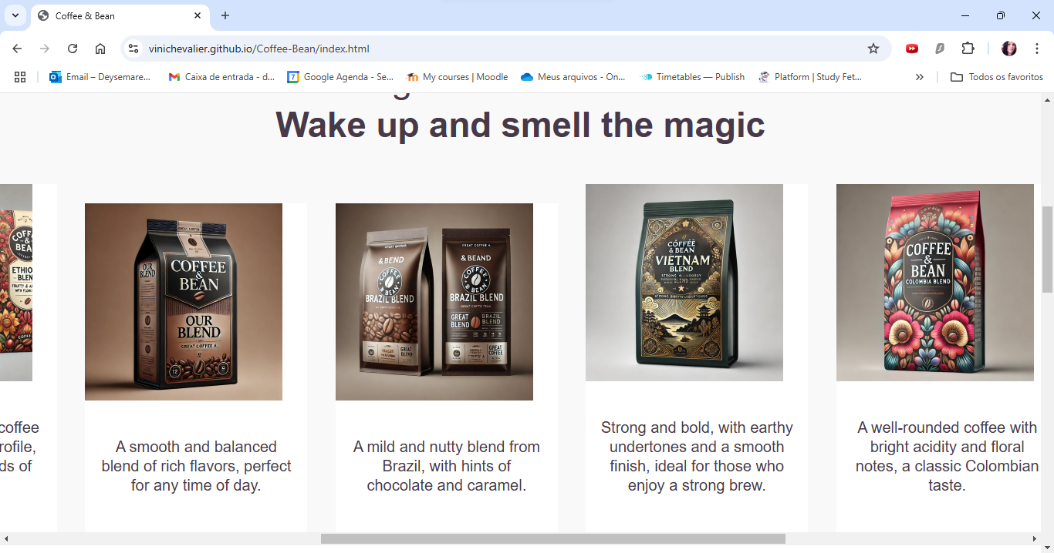

Fig 37. Bean Boutique desktop.

Fig 38. Our Grains desktop.

Fig 39. Our Grains speed Validation.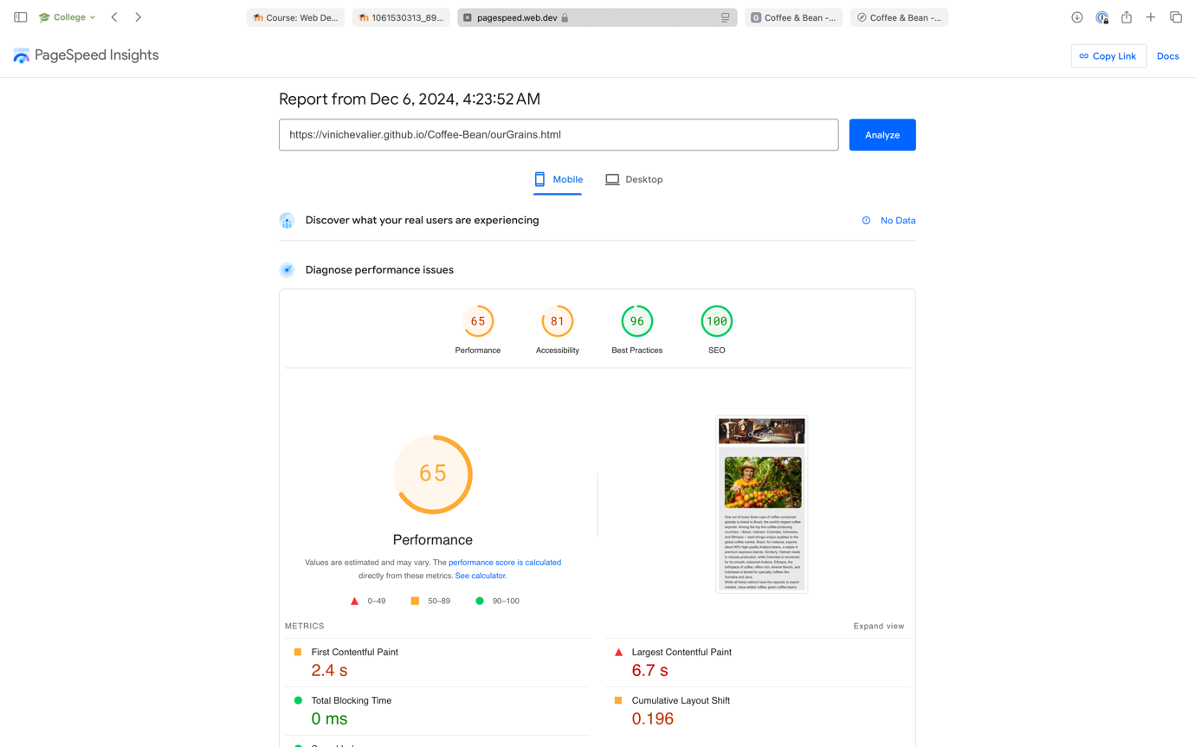

Fig 40. Bean Boutique speed Validation.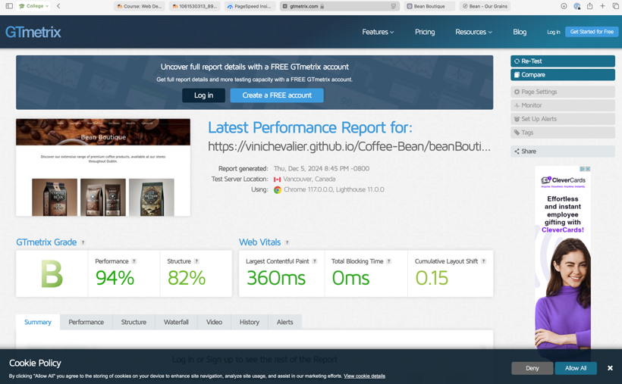

Fig 38. Home (Index) page speed Validation.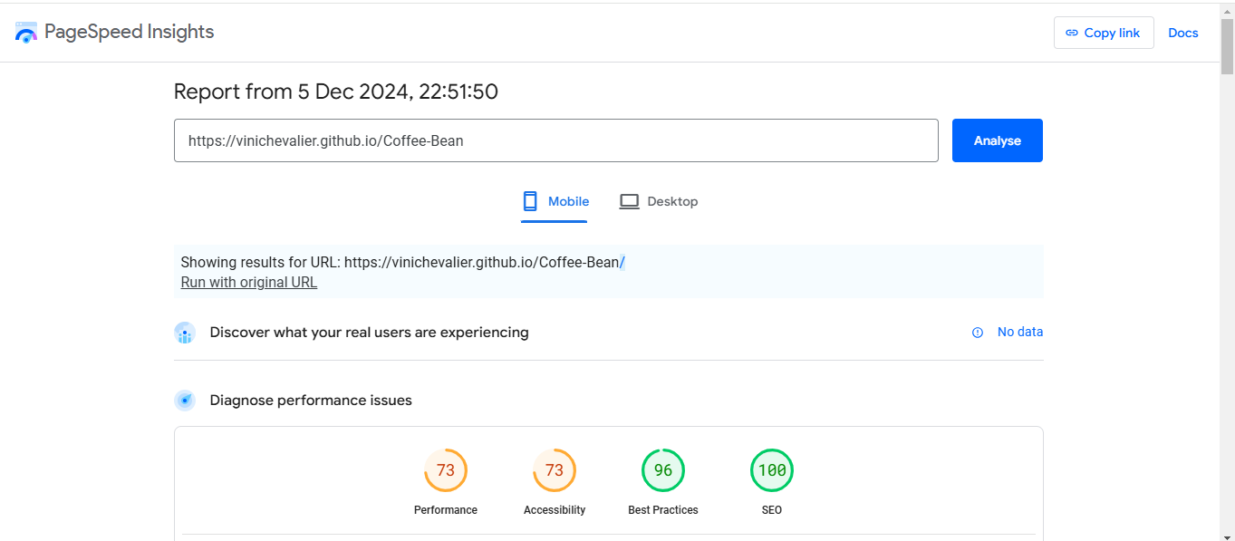

Fig 41. Contact US page speed Validation.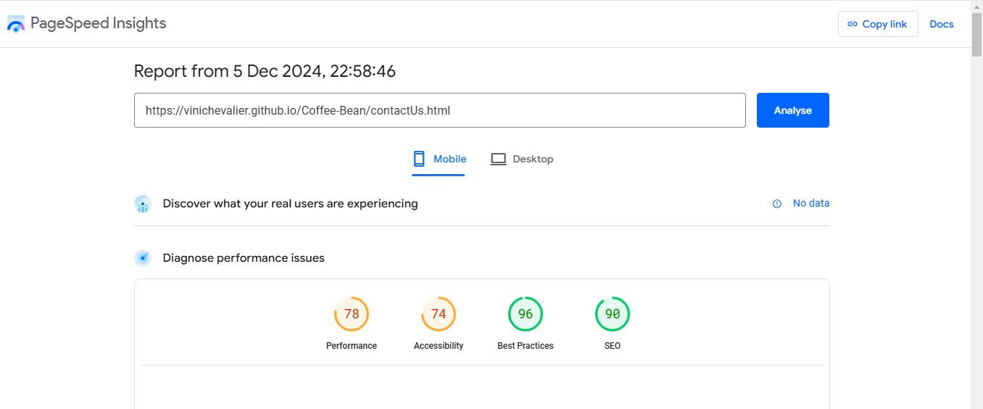

Fig 42. Our Stores speed Validation.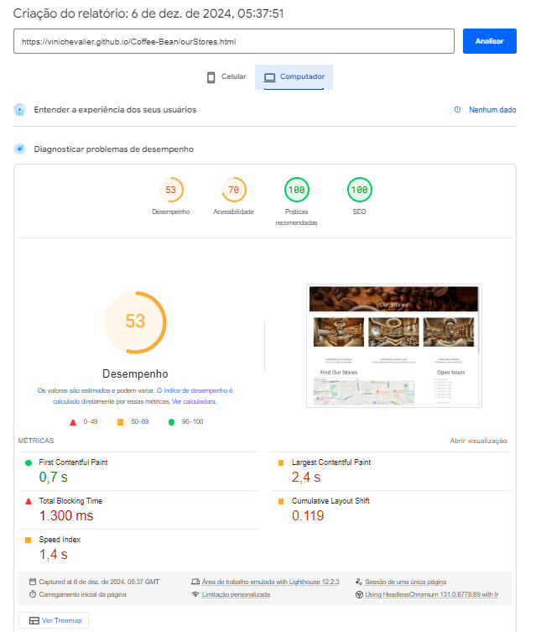

Fig 43. About Us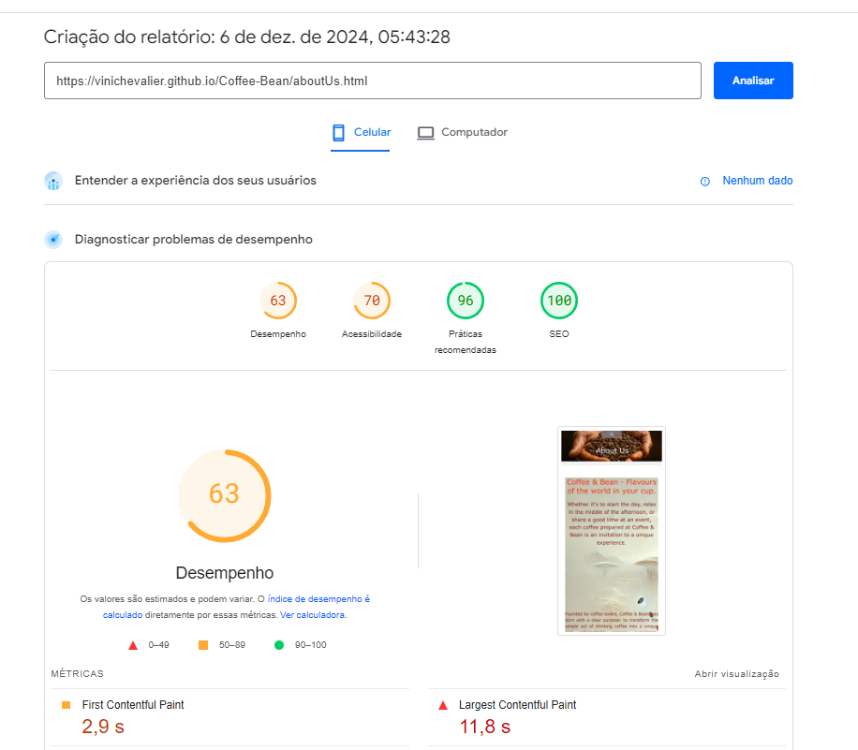

4.5. JavaScript

Offering more quality to the site, the responsiveness can be seen in the texts and images within the tags, but the main point of using JavaScript is the functions that have been implemented. Function ValidateEmail:

The purpose of this JavaScript code is to validate an email address entered by the user in a form and provide feedback based on the validity of the email.

When the user submits the form, the validateForm() function is triggered.

validateEmail() checks if the input is a valid email.They are going to displays "Please enter a valid email address." if the input is invalid or displays "Email is valid." if the input is valid. If invalid, the form is not submitted (return false). If valid, the form submits (return true).

Fig 44. JavaScript Image ValidateEmail.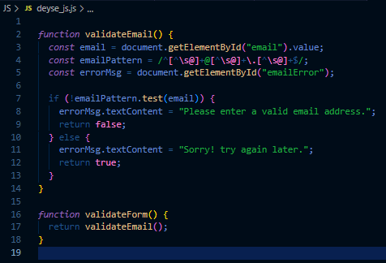

Fig 45. Form Contact Us page

. 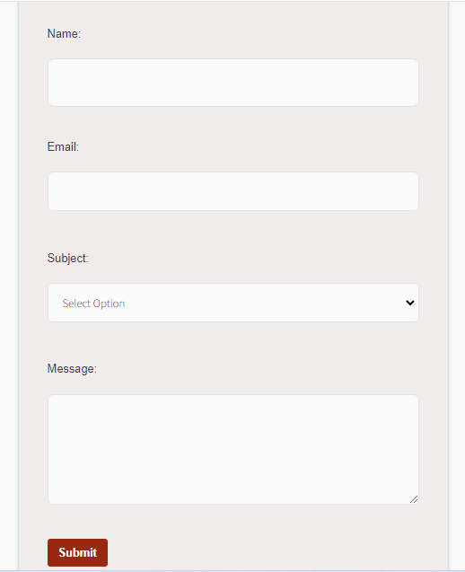

Location selector for shops:

Takes the value from the menu, selects the value and brings up the shop location.

Fig 46. JavaScript statement 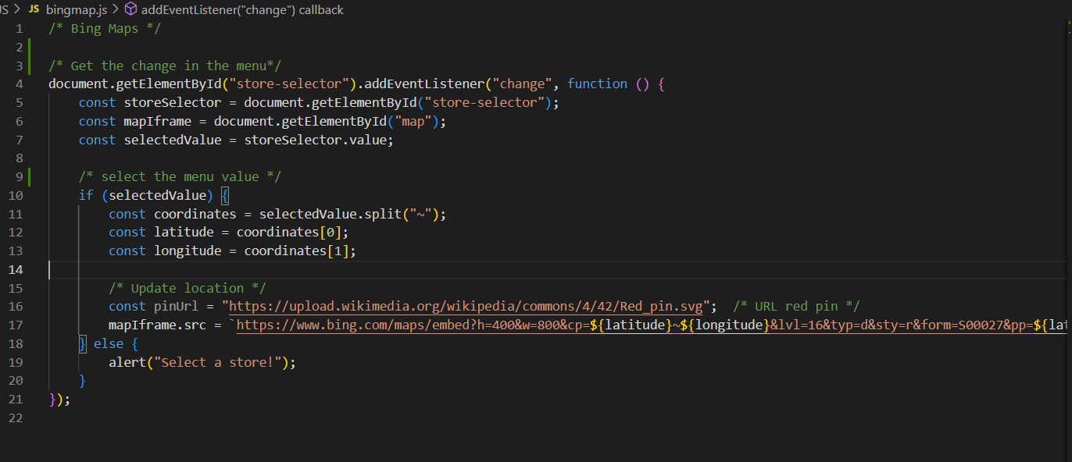

Fig 47. Demonstration of the Bing menu and map.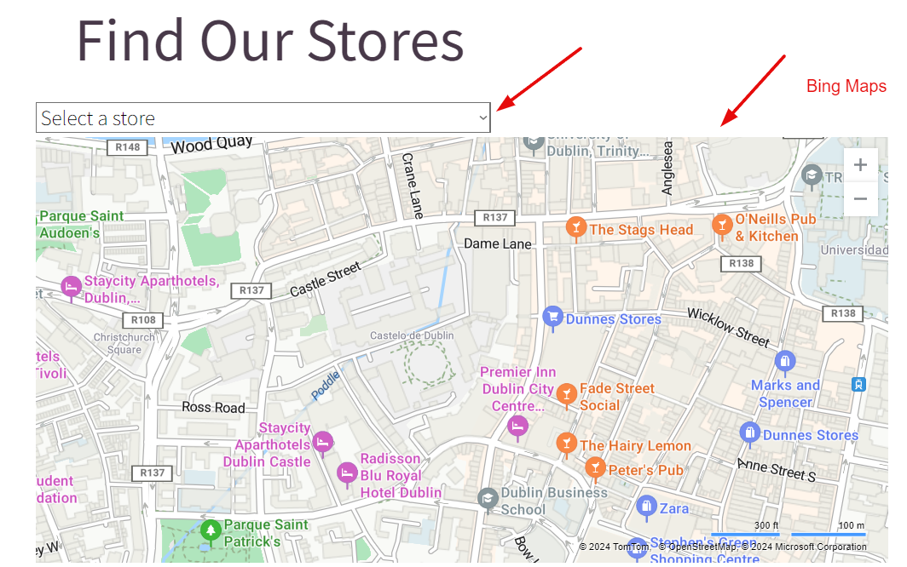

# Conclusion

In order to complete this website, all the knowledge acquired in the classroom was applied and adjacent research carried out so that it would be complete in terms of the time proposed and within what was requested and designed by the group. Obviously during development there were some meetings where tempers flared, but we would say that this strengthened the union and brought more understanding and synergy. We can emphasise that the creation of the website was a good review of everything applied in the classes taught and a good exercise with a deadline.

# Reviews

Fig 48. Gisele Gaynor review.  
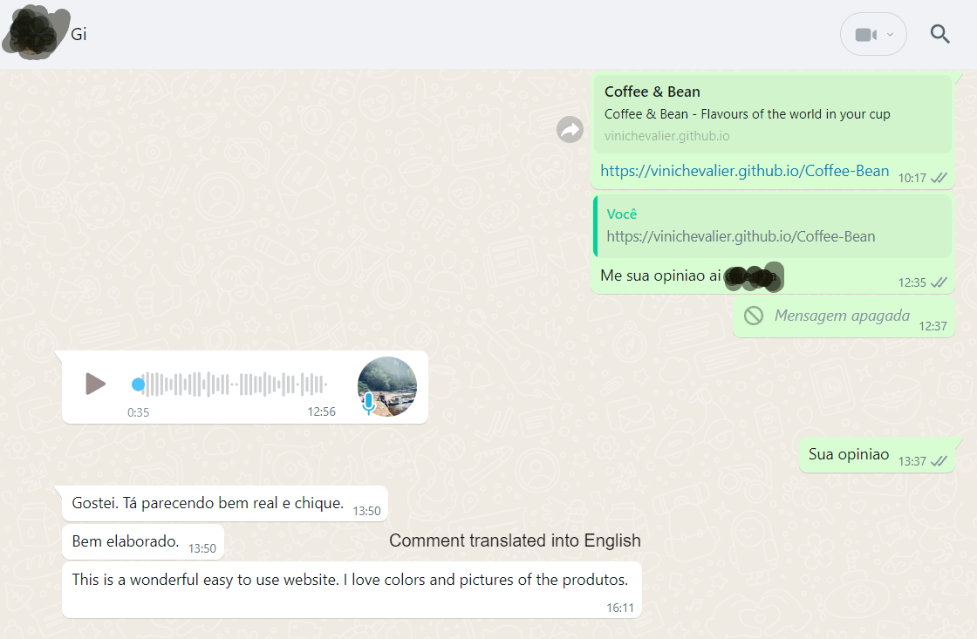

Fig 49. Isabella Macedo review.

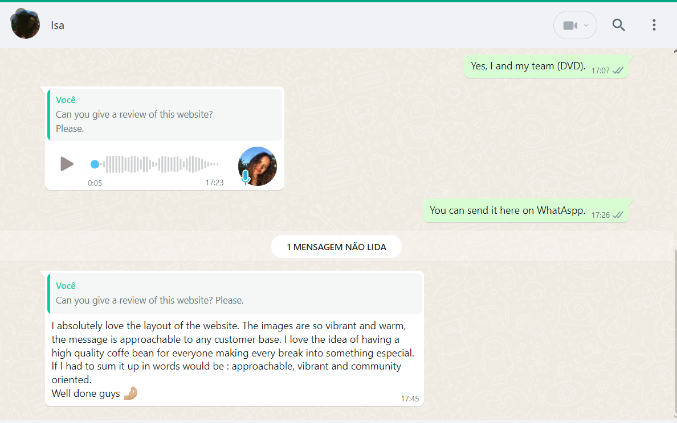

# References

Images criada by ChatGpt [Online]  
 <https://chatgpt.com>

Video Coffee Platation

# 